Python Program Questionnaire.

**List sum**

Description

Suppose you want to know the total score of the Indian cricket team in a given match. To do so, your task is to find the sum of all the scores of the Indian team players. The scores are provided as a list, with each element as an individual score of the players. Also, there is a condition that if the number of elements in the list is more than 11, then it is an invalid input and the output should be -1.

--------------------------------------------------------------------------------------------

Input - List

Output - An integer

--------------------------------------------------------------------------------------------

Sample Input : [11, 13, 101, 14, 33, 141]

Sample Output : 313

---------------------------------------------------------------------------------------------

Sample Input : [11, 13, 101, 14, 33, 141, 12, 144, 54, 67, 8, 11]

Sample Output : -1

---------------------------------------------------------------------------------------------

Sample Input : [100, 80, 30, 10, 0, 1, 2, 0]

Sample Output : 223

**Approach 1:**

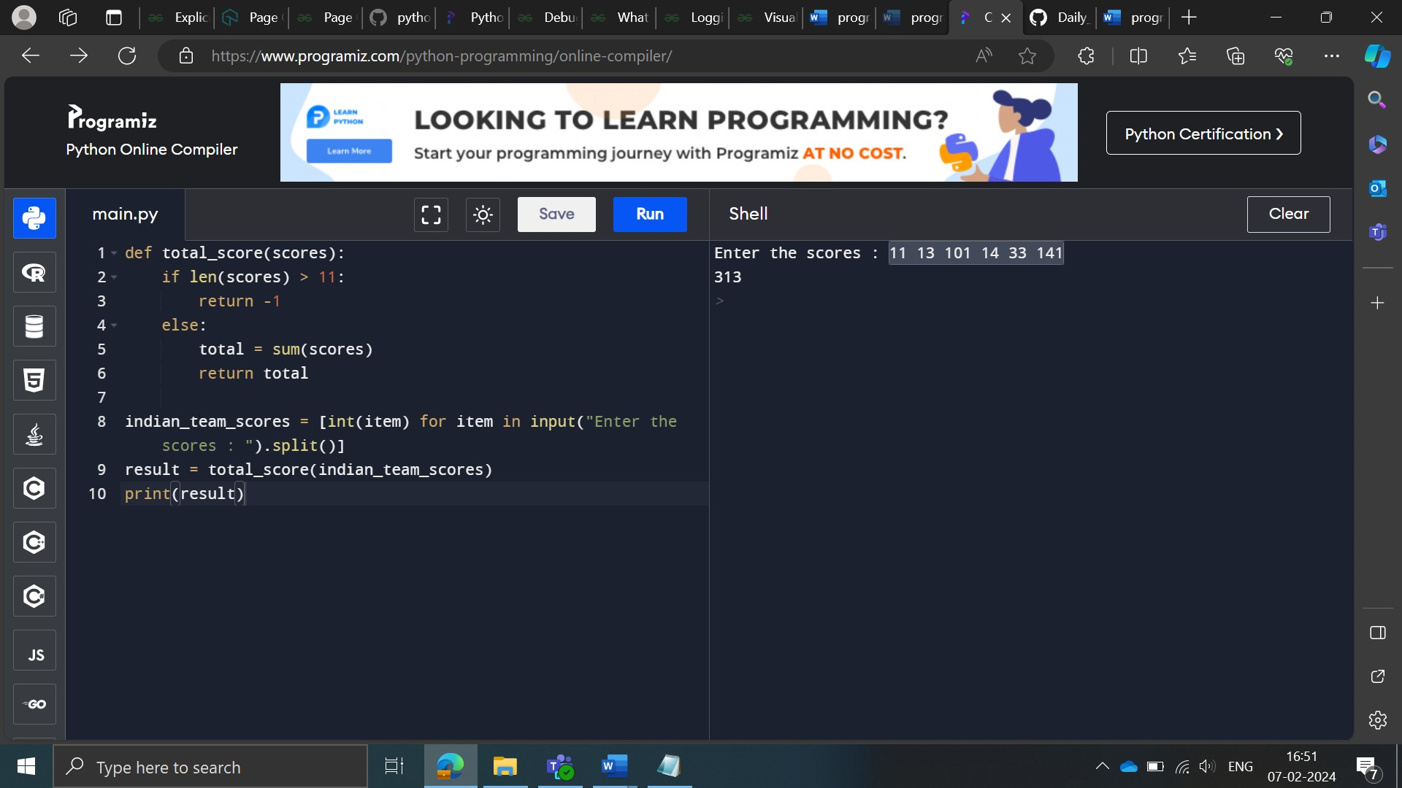

**Approach 2:**

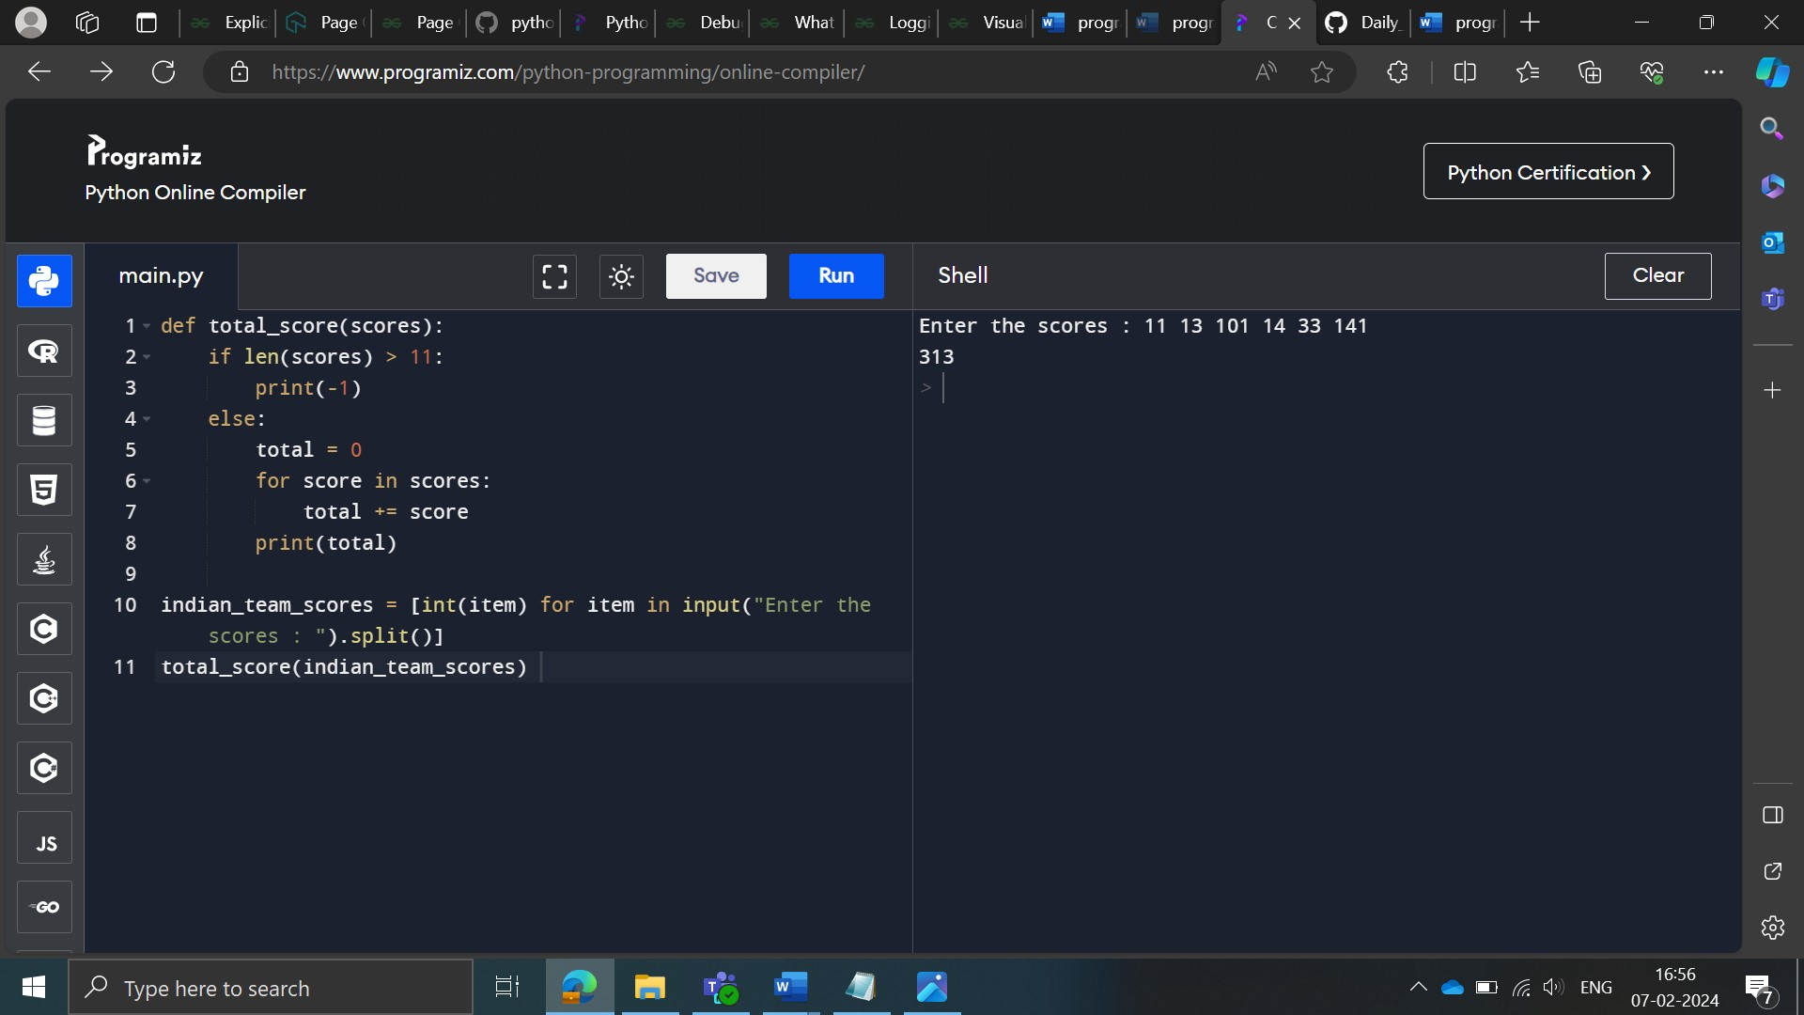

**Length of list elements**

Description

Given a list of strings, write a program to find the number of strings whose length is greater than or equal to K, where K is a positive integer.

Input - List of strings and an integer

﻿Output - Integer

--------------------------------------------------------------------------------

Sample Input: [Mumbai, Hyderabad, Calicut, Chennai]

  K = 9

Sample Output: 1

**Approach 1:**

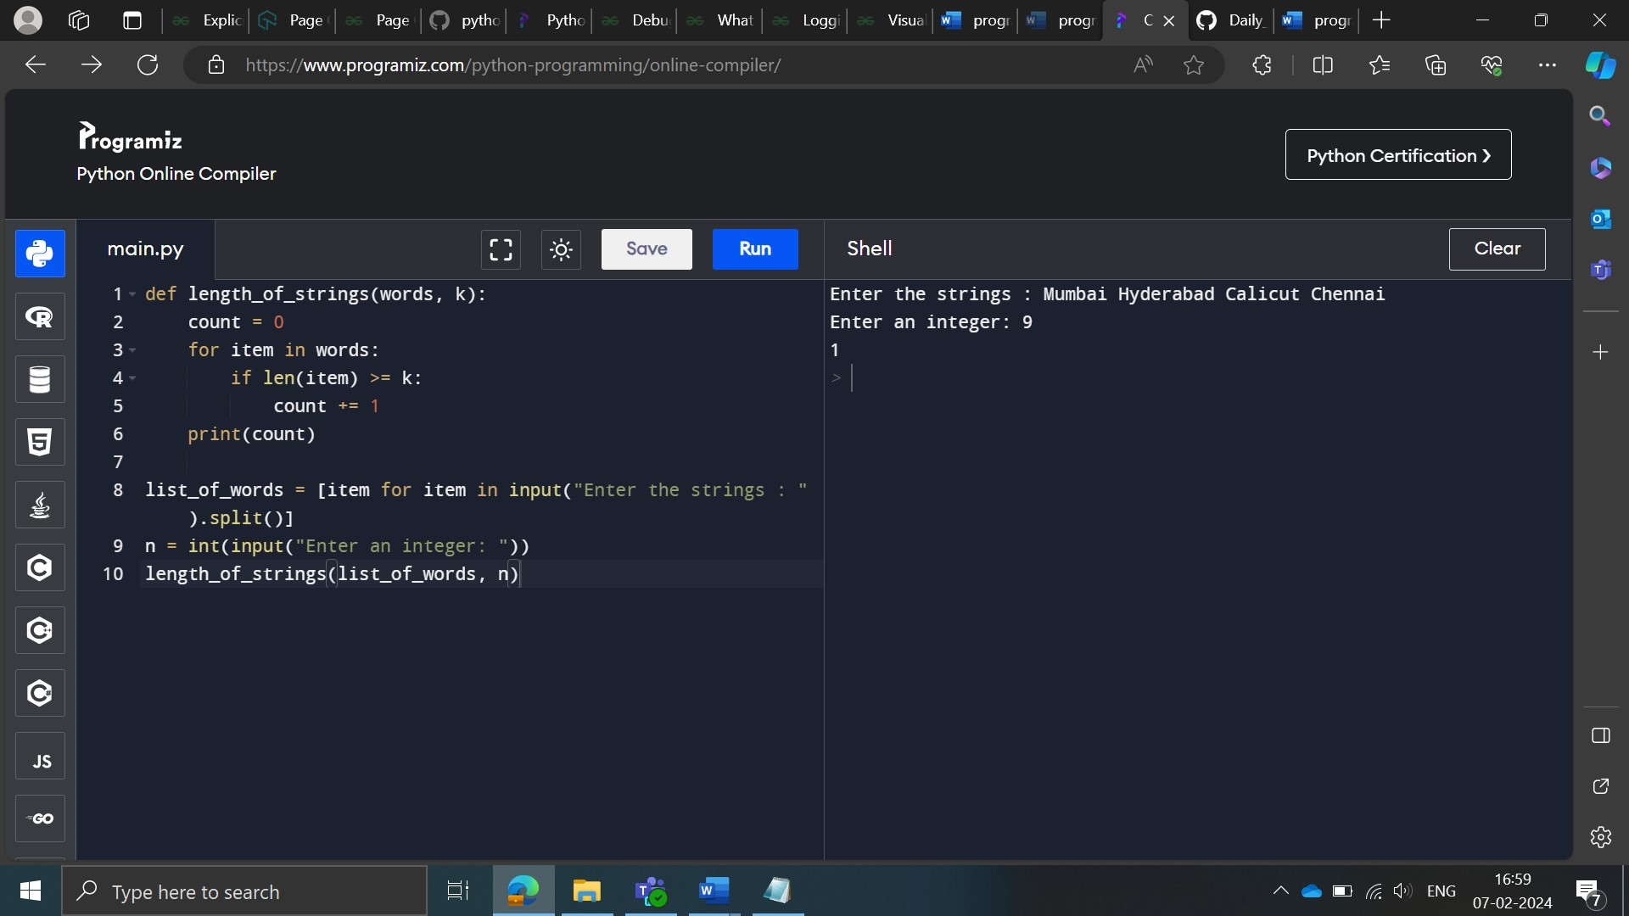

**Approach 2:**

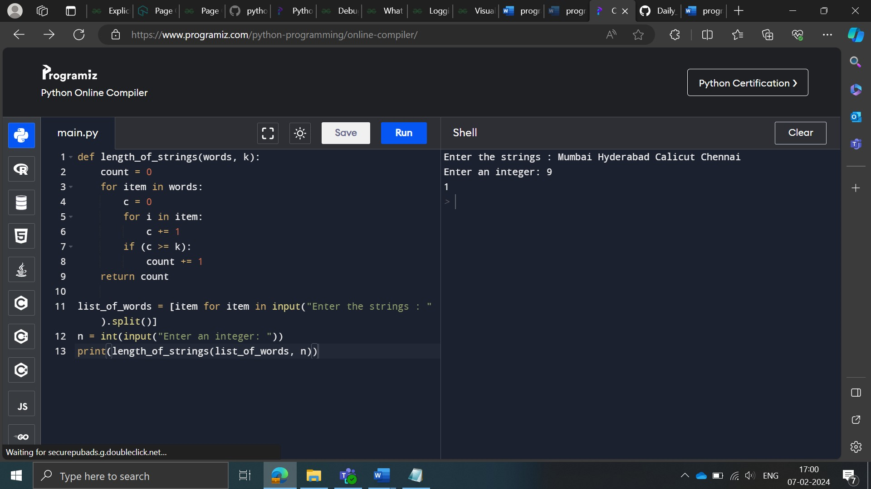

**Approach 3:**

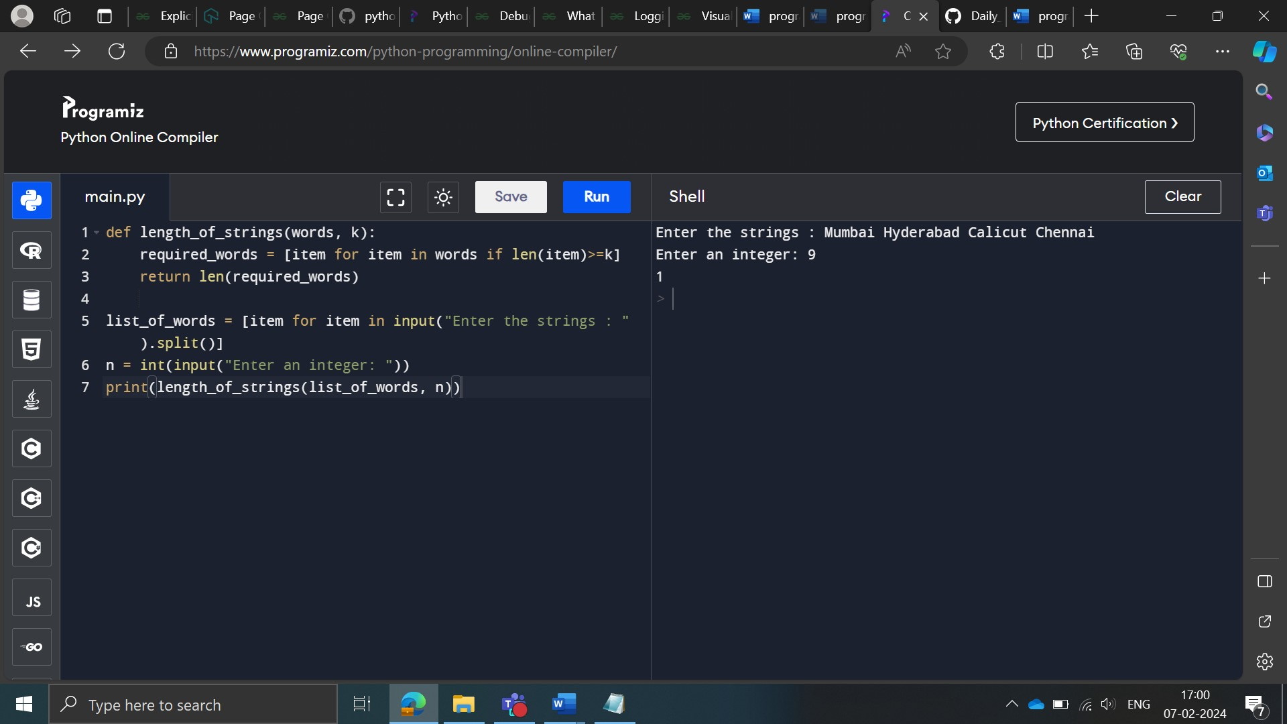

**Increment list elements**

Description

Given a list of strings, increment the value of the numeric strings by 'k’.

Hint: The function [isdigit()](https://stackoverflow.com/questions/49742938/checking-isdigit-on-python/49768079" \l ":~:text=isdigit()%20is%20a%20method,input()%20with%20raw_input()%20." \t "_blank) may be useful here.

---------------------------------------------------------------------------------------------

Input - A list in the first line and an integer in the second line

Output - A list

---------------------------------------------------------------------------------------------

Sample Input :

['Python', '123', 'Data']

 K= 4

Sample Output : ['Python', '127', 'Data']

---------------------------------------------------------------------------------------------

Sample Input :

[‘City’, '1991', 'Mumbai']

 K= 0

Sample Output : [‘City’, '1991', 'Mumbai']

**Approach 1:**

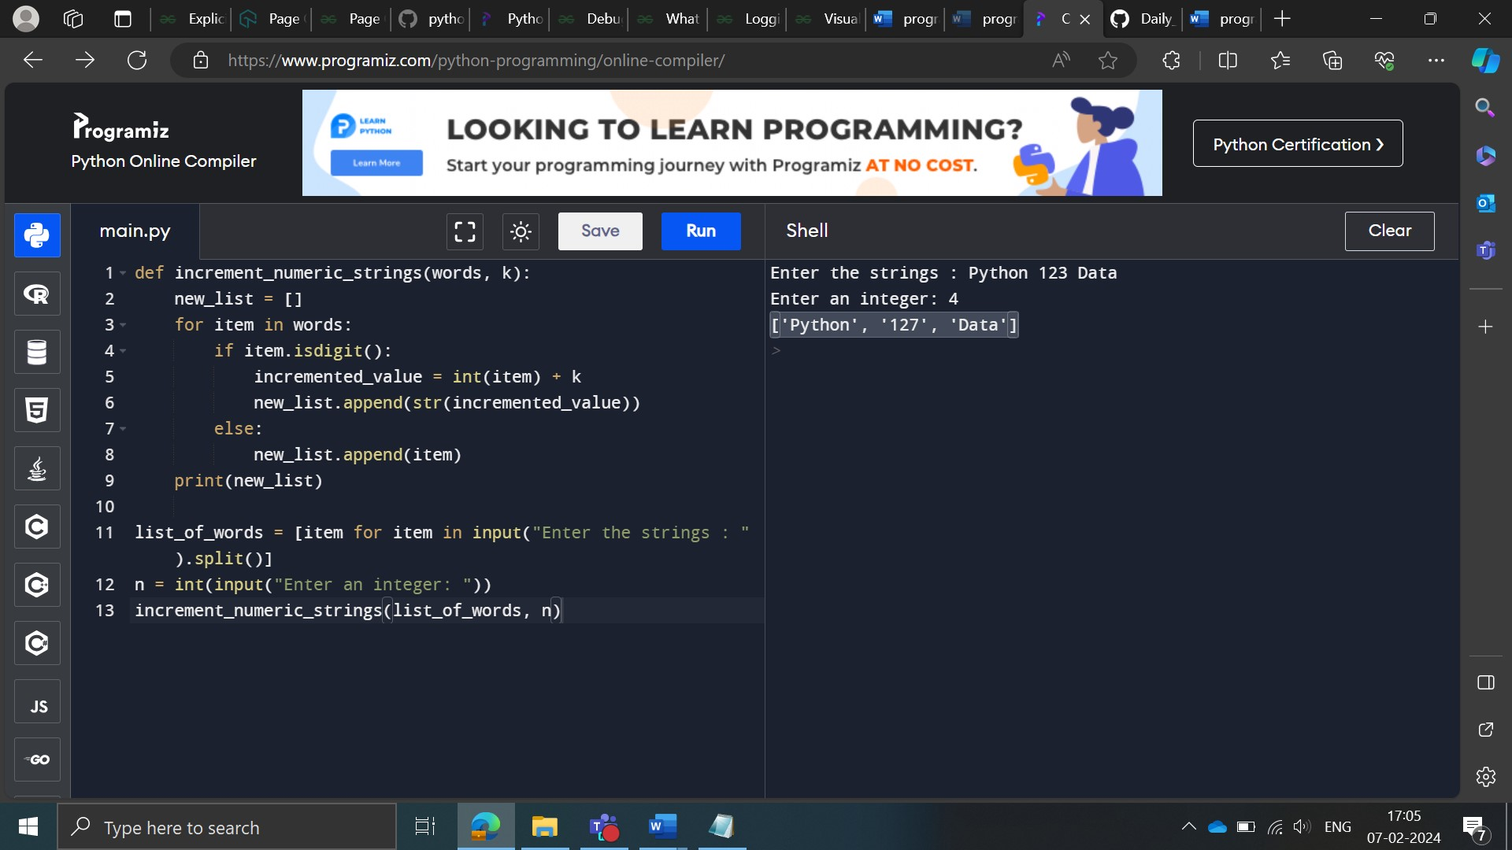

**Approach 2:**

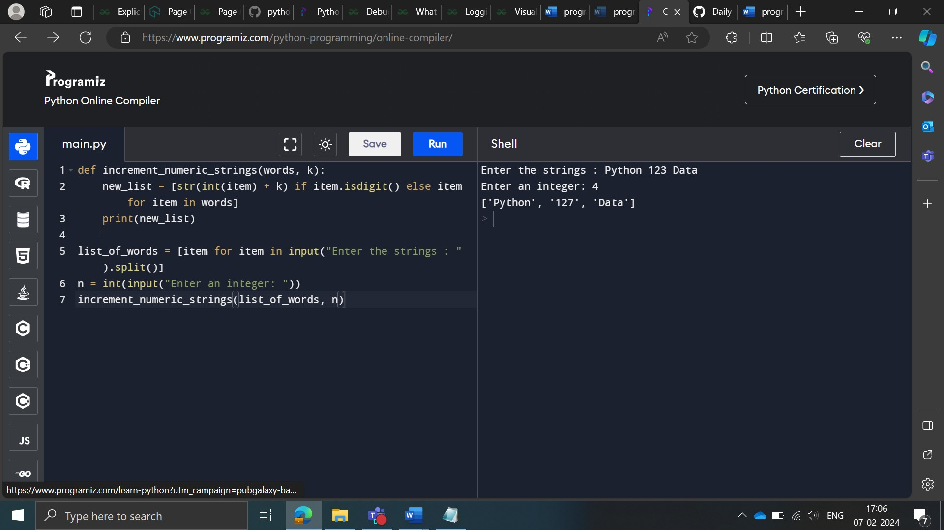

**Approach 3:**

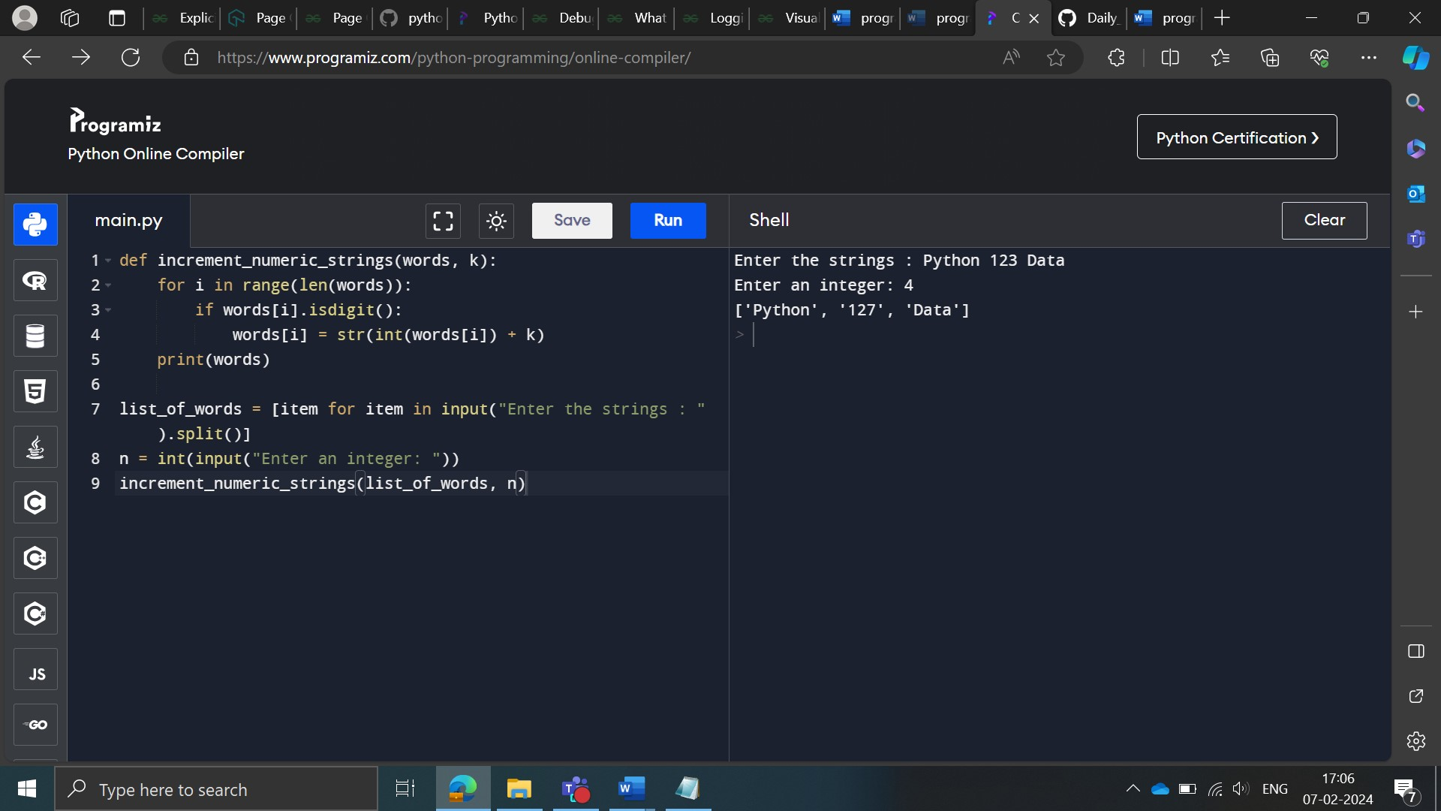

**Even numbers in a list**

Description

Given a list of integers, write a python code to find all the even numbers present in the list.

Note: Try using lambda and filter functions to solve the problem.

Input: A list of integers

Output: A list of integers

----------------------------------------------------------------------

Sample input: [5, 7, 22, 97, 54, 62, 77, 23, 73, 61]

Sample output: [22, 54, 62]

----------------------------------------------------------------------

Sample input: [500, 789, 2112, 9097, 5894, 9062, 8977, 1223, 773, 600]

Sample output: [500, 2112, 5894, 9062, 600]

**Approach 1:**

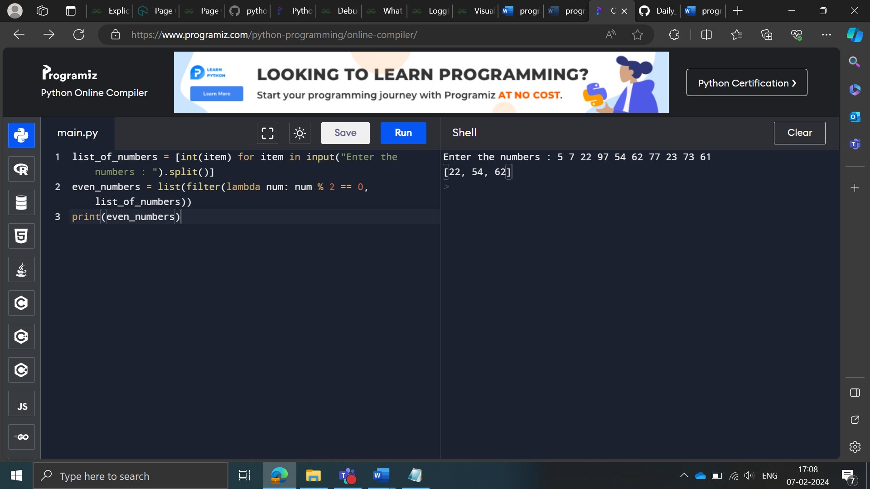

**Approach 2:**

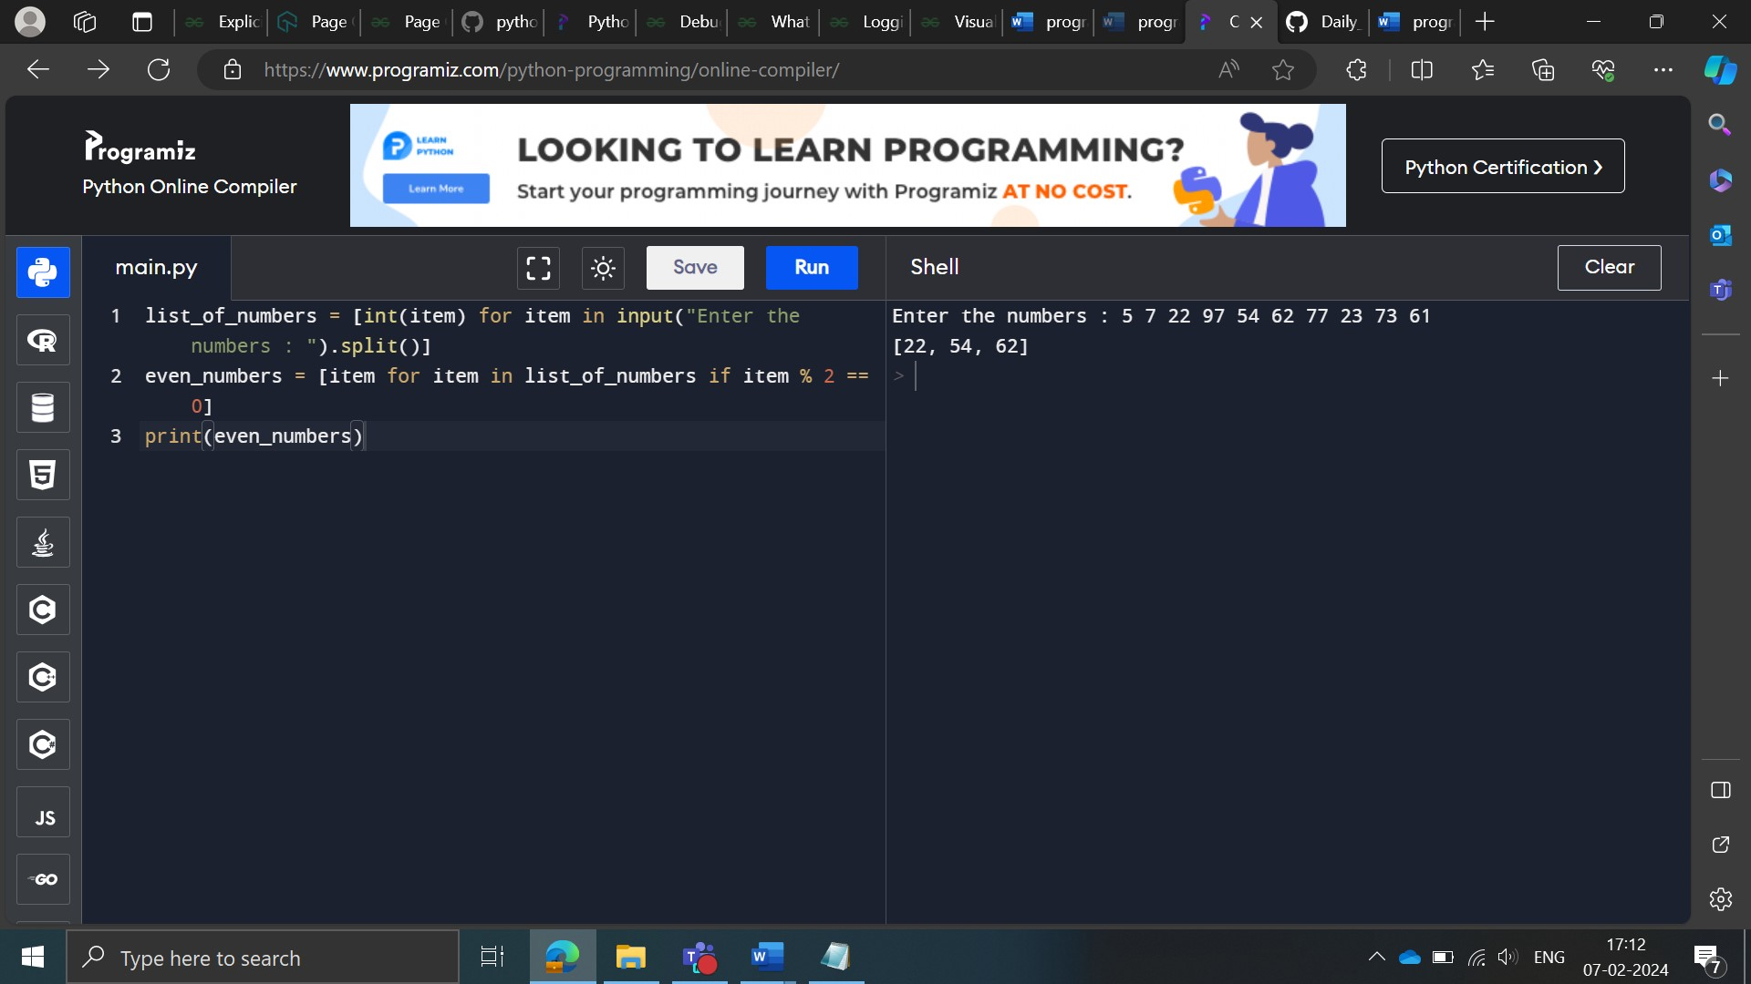

**Triple the list elements**

Description

Given a list of integers, write a python code to triple all the values in the list.

Note: Try using lambda and map functions to solve the problem.

Input: A list of integers

Output: A list of integers

----------------------------------------------------------------------

Sample input: [5, 7, 22, 97, 54, 62, 77, 23, 73, 61]

Output: [15, 21, 66, 291, 162, 186, 231, 69, 219, 183]

----------------------------------------------------------------------

Sample input: [15, 71, 2, 9, 5, 6, 11, 3, 7, 6]

Output: [45, 213, 6, 27, 15, 18, 33, 9, 21, 18]

**Approach 1:**

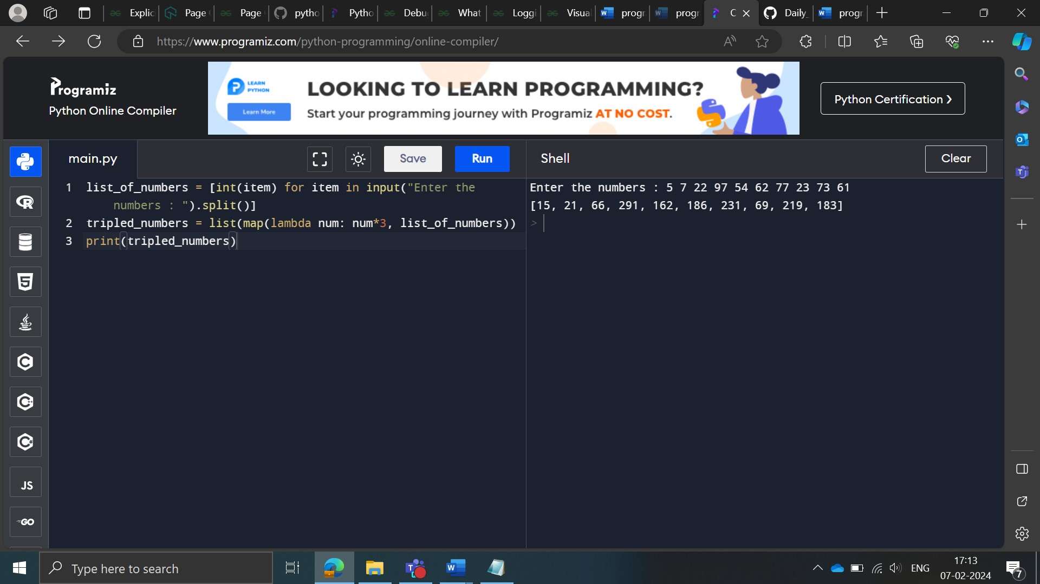

**Approach 2:**

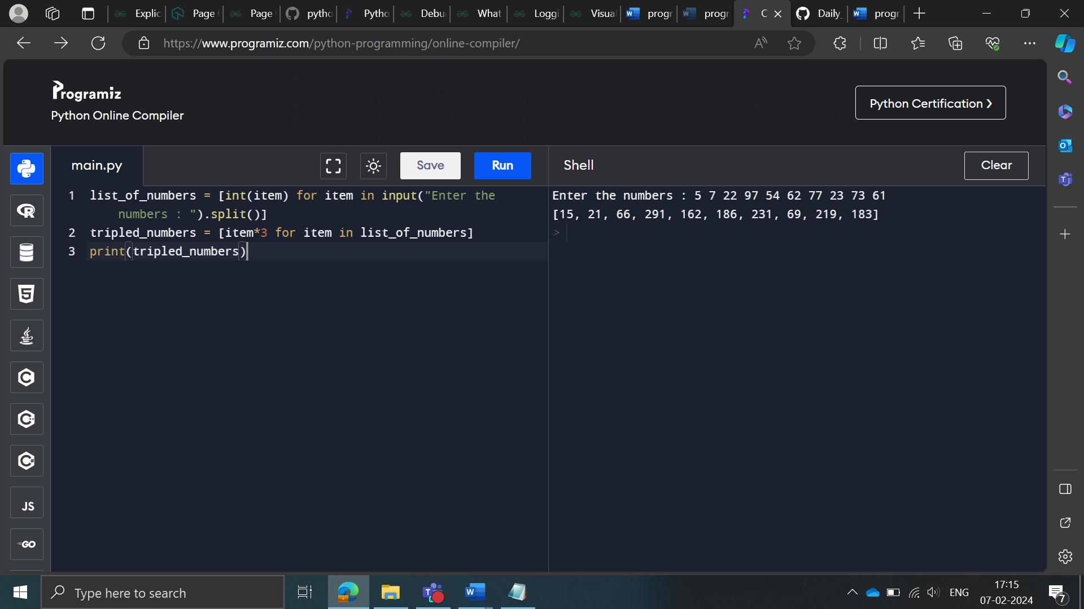

**Approach 3:**

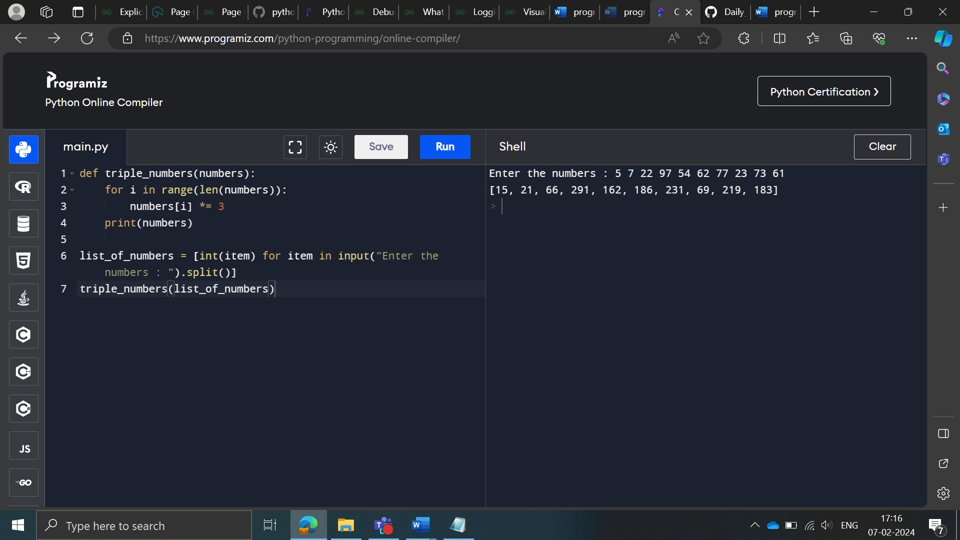

\*\*\*\*\*\*\*\*\*\*\*\*\*\*\*\*\*\*\*\*\*\*\*\*\*\*\*\*\*\*\*\*\*\*\*\*\*\*\*\*\*\*\*\*\*\*\*\*\*\*\*\*\*\*\*\*\*\*\*\*\*\*\*\*\*\*\*\*\*\*\*\*\*

Encrypt elements in a list

Description

A company stores the names of their employees in a list. They want to encrypt the names so that no one can read them and the data stays safe. One of the steps in encrypting is to reverse each name in the list and convert them to uppercase and your task is to write a Python code to execute the same.

Note: Use lambda and map functions.

Input: A list of names

Output: A list of encrypted names

----------------------------------------------------------------------

Sample input: ['Ronaldo', 'Cristiano', 'Rakesh', 'Ronak']

Sample output: ['ODLANOR', 'ONAITSIRC', 'HSEKAR', 'KANOR']

----------------------------------------------------------------------

Sample input: ['Abhay', 'Aravind', 'Desilva', 'Darpan']

Sample output: ['YAHBA', 'DNIVARA', 'AVLISED', 'NAPRAD']

**Approach 1:**

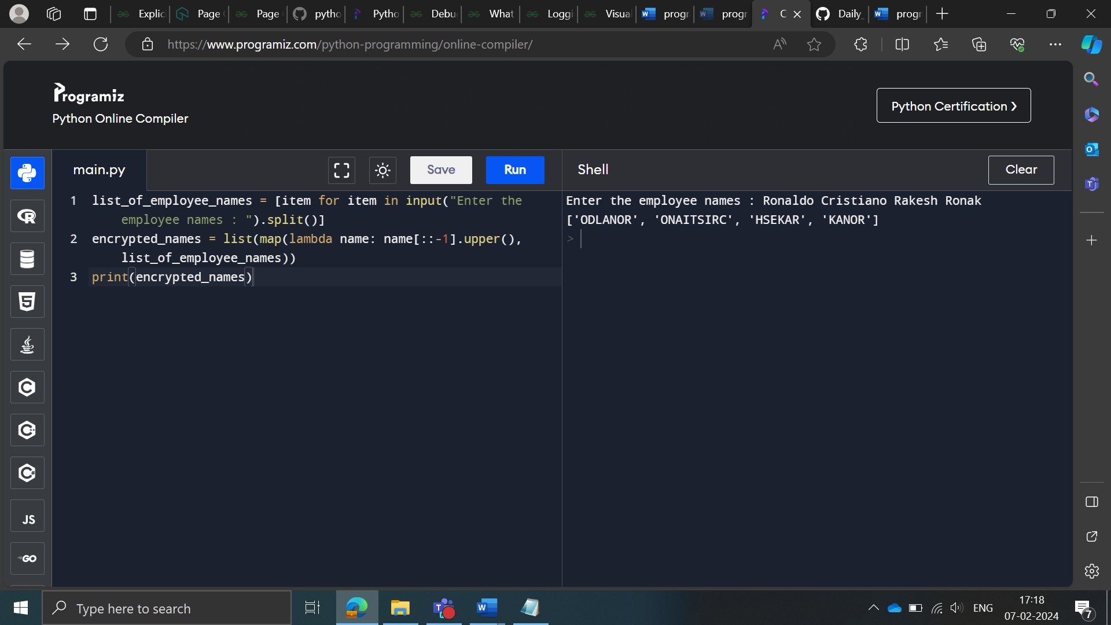

**Approach 2:**

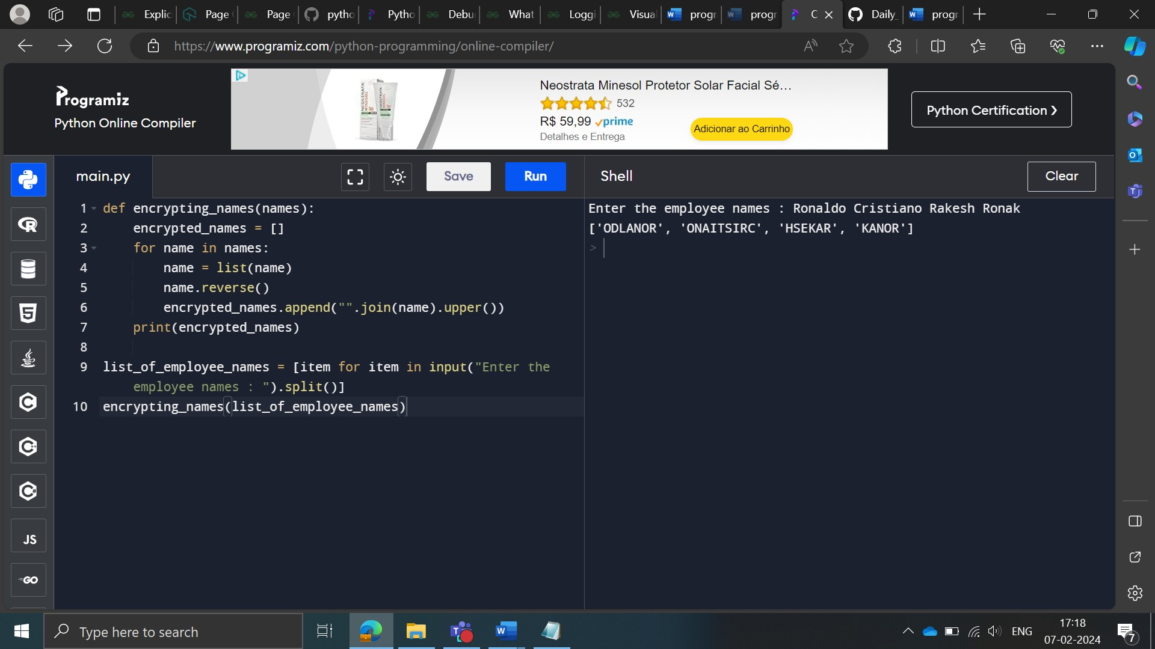

**Sorting a dictionary**

Description

Given is a list consisting of dictionary elements. Each dictionary contains the name of a student as a first item and his/her corresponding rank as the second item. Your task is to write a Python program to print the list (dictionary elements) in a sorted ascending order according to student ranks. In case the rank of two or more students are the same, then sort them in ascending order (alphabetically) according to their names.

Note: Use the sorted () function to solve the question.

Input: Dictionary

Output: Dictionary

----------------------------------------------------------------------

Sample input: [{ "name" : "Arpit", "rank" : 20}, { "name" : "Manjeet", "rank" : 20 },{ "name" : "Aravind" , "rank" : 19 }]

Sample output: [{ "name" : "Aravind" , "rank" : 19 }, { "name" : "Arpit", "rank" : 20}, { "name" : "Manjeet", "rank" : 20 },

]

**Approach 1:**

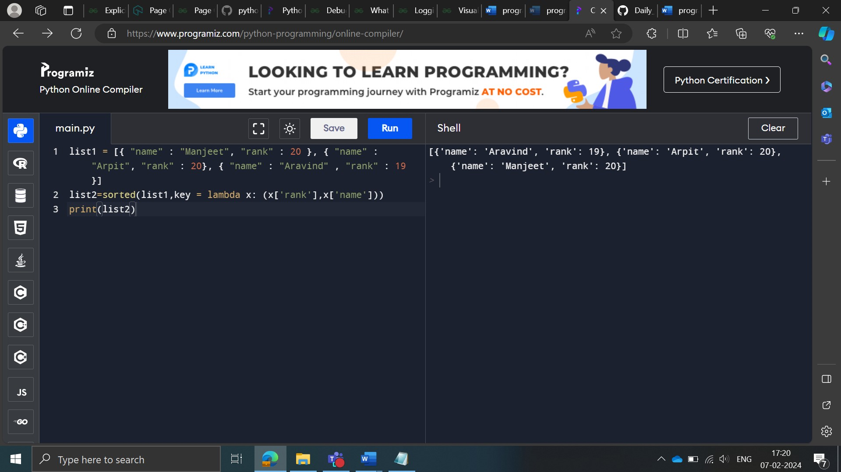

**Approach 2:**

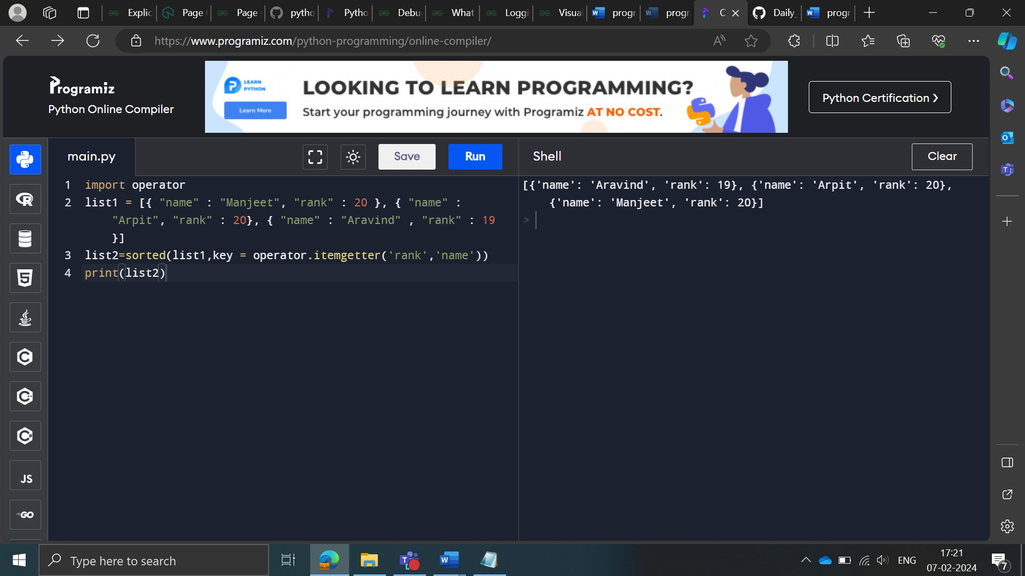

**Intersection of lists**

Description

In ‘ABC’ university, company ‘XYZ’ conducted three rounds of interviews to recruit students. Those students who passed all the rounds were selected. The company released the results for each round in a separate list. Your task is to write a Python code to display the list of the students who passed all the three rounds.

Note: a. Name of the person can be given in uppercase or lowercase.

 b. Print the names in lowercase in the output.

Input: List

List

List

Output: List

----------------------------------------------------------------------

Sample input: ['Arkam', 'Bairstow', 'Cairy', 'Darpan']

 ['ARKAM', 'Bairstow', 'Cairy', 'Darpan', 'Dhoni', 'Sachin']

 ['arkam', 'bairstow', 'Cheteshwar', 'Dinesh']

Sample output: ['arkam', 'bairstow']

----------------------------------------------------------------------

Sample input: ['Pranay', 'Aditya', 'Deepesh', 'Sandesh']

['Pranoy', 'Surya', 'Cairy', 'Vignesh', 'ADITYA', 'SANDesh']

['Vardhan', 'Shailesh', 'aditya', 'sandesh']

Sample output: ['aditya', 'sandesh']

----------------------------------------------------------------------

Sample input: ['Siddharth', 'Gaurav', 'Prasad', 'Kuldeep', 'karna']

['siddharth', 'Gaurav', 'Prasad', 'Kuldeep', 'karna']

['Siddharth', 'gaurav', 'PRASAD', 'KuLDEEp', 'KARNA']

Sample output: ['siddharth', 'gaurav', 'prasad', 'kuldeep', 'karna']

**Approach 1:**

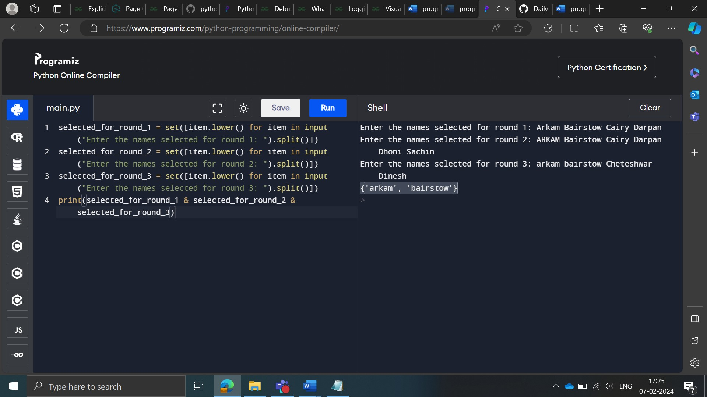

**Approach 2:**

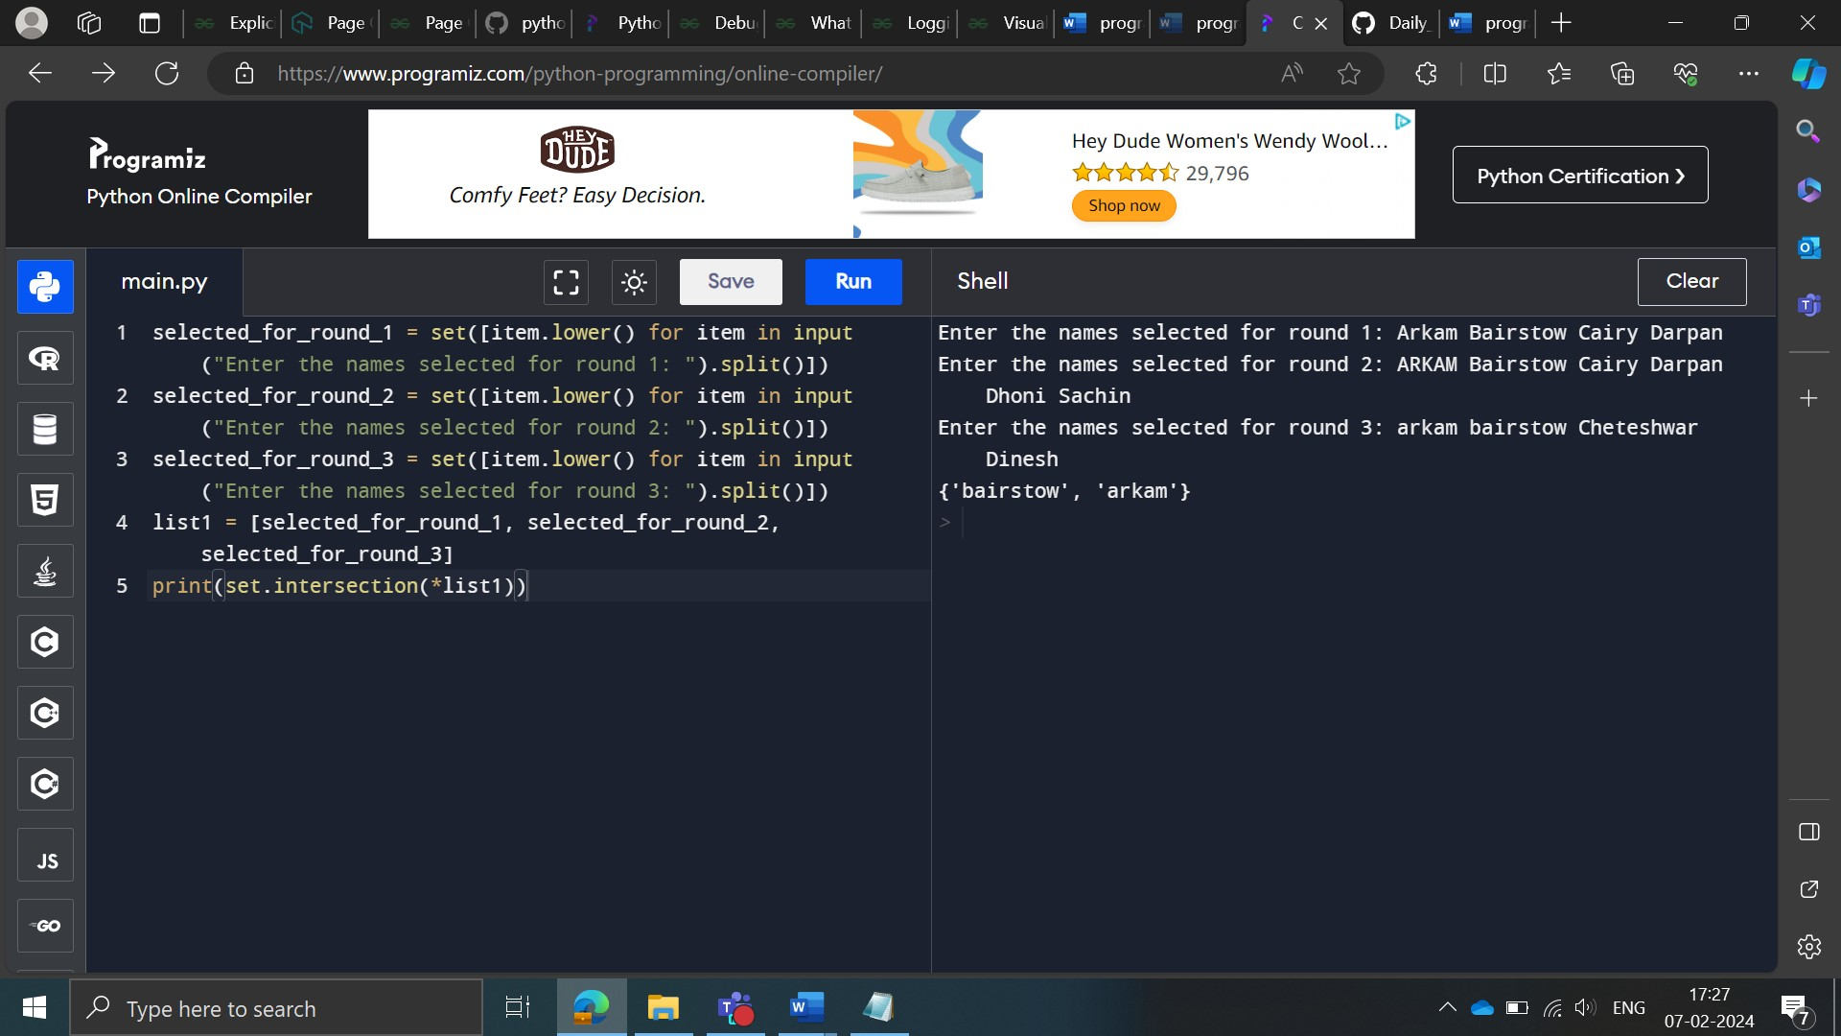

Sorting a list of dictionary elements

Description

A teacher decided to divide the class into groups to conduct fun activities. Each group had one or more members in it. The data is provided in the form of a list with dictionary elements. The key and value in each dictionary correspond to the student’s roll number and his/her name.

In case the length of two or more dictionaries are the same, then the dictionary that occurs first in the input list will also appear first among the other dictionaries of the same length.

Your task is to write a Python program to sort the list in descending order with respect to the group strength.﻿

Note: Use lambda and sorted functions to solve the question.

Input: List

Output: List

----------------------------------------------------------------------

Sample input: [{4: 'Viking', 9: 'Happy', 10: 'Tony', 2: 'Rogers'}, {12: 'Vikram', 19: 'Vipan'}, {3: 'Kohli'}, {1: 'Ronaldo', 29: 'Harish', 7: 'Ganesh'}]

Sample output: [{4: 'Viking', 9: 'Happy', 10: 'Tony', 2: 'Rogers'}, {1: 'Ronaldo', 29: 'Harish', 7: 'Ganesh'}, {12: 'Vikram', 19: 'Vipan'}, {3: 'Kohli'}]

**Approach 1:**

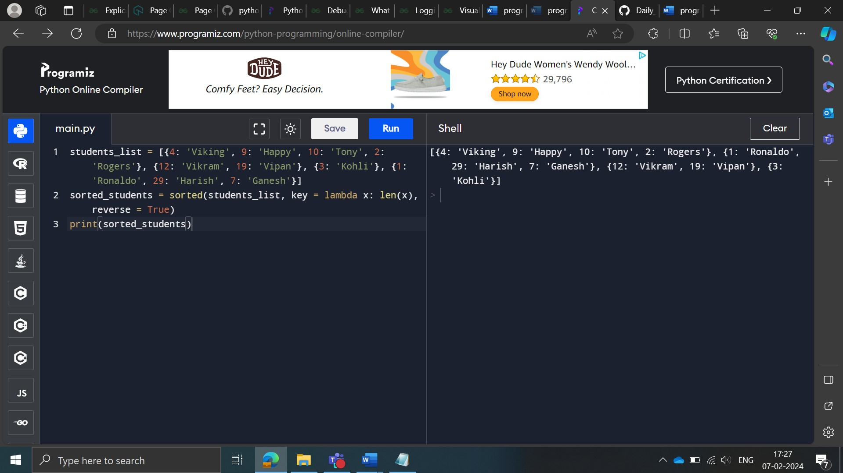

**Approach 2:**

